Western Alliance for Greenhouse Action

Annual Report 2014-2015

Who is WAGA?

***Western councils leading and supporting collaborative action to decrease greenhouse gas emissions and increase the adaptive capacity of their communities through partnerships between local communities, businesses, government and research bodies***

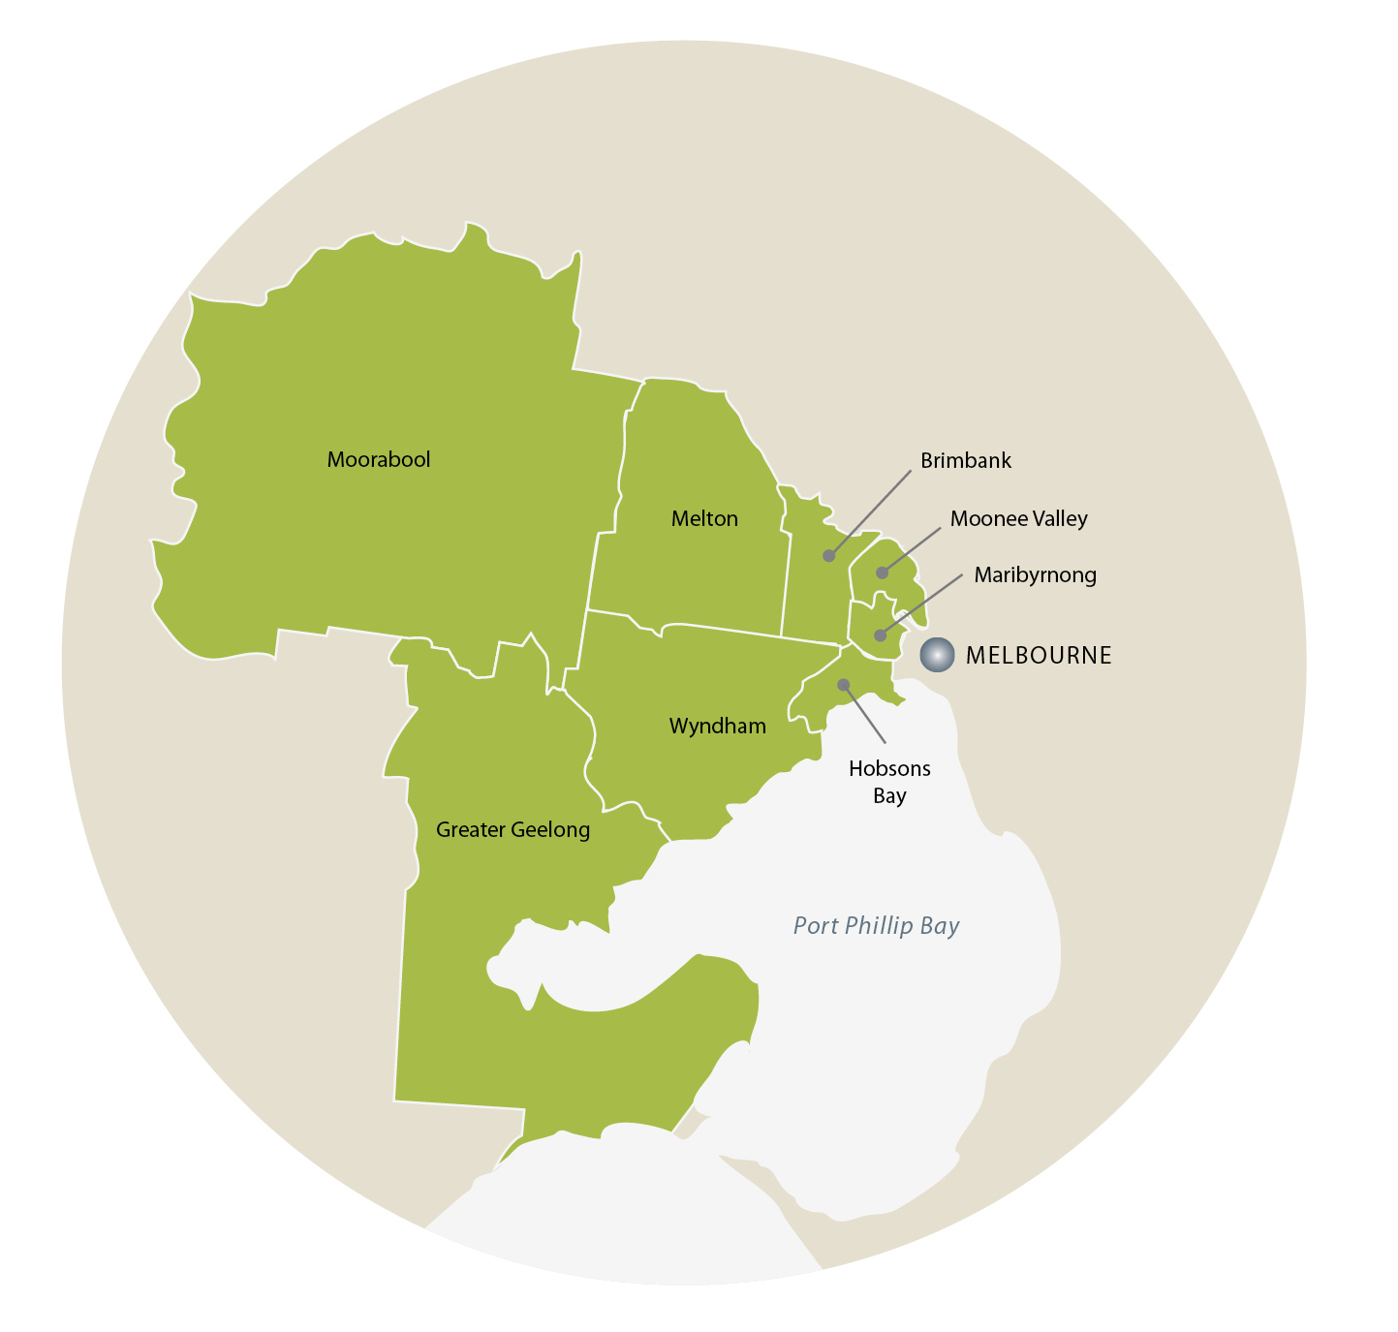WAGA is a local government partnership of eight councils: Brimbank, Greater Geelong, Hobsons Bay, Maribyrnong, Melton, Moonee Valley, Moorabool and Wyndham.

Messages from the Chair

Natalie Walker, Director of Strategic Development at Hobsons Bay City Council, continued in the Chair until the end of her term in December 2014. She handed on the position for a one-year term to Adrian Murphy, Manager of Economic Development and City Sustainability at Moonee Valley City Council. Natalie continues to represent Hobsons Bay on the WAGA Executive Committee.

Message from Natalie Walker, WAGA Chairperson, 2011-2014:

'The development and launch of Low Carbon West in 2014 is a significant milestone for WAGA. It is a partnership project with LeadWest and Western Melbourne Regional Development Australia, two organisations in the west with a focus on economic development. Low Carbon West emphatically acknowledges that reducing greenhouse gas emissions is an economic issue and can lead to opportunities for businesses and job creation, as well as direct cost savings.

Low Carbon West Is intended to guide WAGA's work in the region on carbon mitigation for the next five years. It complements the WAGA councils' ongoing work to reduce their corporate greenhouse gas emissions through a change-over to energy-efficient street lighting as well as efficiency upgrades of council buildings and facilities. These actions put the WAGA councils in a great position to show continuing regional and indeed Victoria-wide leadership and collaboration in emissions reduction and energy efficiency.

It has been a pleasure to be involved in the development of WAGA's main strategies, and I now look forward to being part of the implementation team.'

Message from Adrian Murphy, current WAGA Chairperson:

'I'd like to thank Natalie Walker for her leadership of WAGA over the last four years. During this time, WAGA's work has stabilised under the banner of Low Carbon West and the regional Adaptation Strategy, the alliance has formed ongoing positive partnerships with key stakeholders, and its profile has accordingly grown. WAGA's governance has been robust, and the alliance can confidently assure its member councils that it will lead and manage strong action to address climate change issues across the western region.

WAGA's most important task in 2015 is to develop a coordinated program to help businesses in the region reduce their own greenhouse gas emissions. I am committed to leading WAGA in successfully meeting this challenge.'

Achievements in 2014-2015

Low Carbon West

Low Carbon West, a plan for transition to a low carbon economy in the western region of Melbourne, has been developed by WAGA in partnership with [LeadWest,](http://www.leadwest.com.au/) also an alliance of western councils, and [Western Melbourne Regional Development Australia](http://www.rdv.vic.gov.au/regional-development-australia/western-melbourne). The following actions have been undertaken to finalise and commence implementation of the plan:

* Six of the WAGA councils endorsed the plan, October 2015-February 2016.
* In November 2015, the plan was launched with approximately 80 stakeholders, including Councillors and CEOs of the WAGA councils, at the Incinerator Gallery in Moonee Valley.
* Since February 2015, Low Carbon West has been presented at regional events and to stakeholders outside the region, including a business seminar by a local manufacturing business for World Environment Day, RMIT University's Eco-city Urban Ecology Symposium and a delegation of councils, the South West Group, from Western Australia. The plan was also introduced to key Victorian Government ministers, the Minister for the Environment and the Minister for Industry, Energy and Resources.
* The plan was promoted in Brimbank's 'Link' newsletter and by community radio show 'The Sustainable Hour' in Geelong.
* The Low Carbon West Project Steering Group met monthly and began to develop a program plan to reduce greenhouse gas emissions from non-residential buildings, to be finalised by the end of 2015.
* WAGA continued to advocate to the Victorian Government to support Environmental Upgrade Agreements (EUAs) for Victorian councils and began conversations internally with WAGA councils to inform them about the potential of EUAs and the logistics of establishing EUAs projects. The WAGA Coordinator also participated in the Expert Stakeholder Roundtable on Energy Efficiency and Productivity, 12 March 2015, which contributed to development of the Government's Energy Efficiency and Productivity Statement. (This led to further contributions in an industrial workshop and the Energy Efficiency and Productivity Summit in August 2015.)
* WAGA's Operational Committee has been sharing information, hearing from experts and discussing what makes a residential emissions reduction program work.

Lighting the West

This project involves a bulk change-over of street lights to energy-efficient luminaires in the region. Lighting the West is potentially Australia's largest greenhouse gas-saving lighting project. In 2014,2015,

* Change-over of 13,019 street lights was completed across Hobsons Bay, Maribyrnong, Moonee Valley and Wyndham.
* Public communications were rolled out across participating councils and included community workshops, billboards, footpath stickers and ‘speed dating’ with a sustainability consultant.

See the [Lighting the West](http://www.lightingthewest.com.au/) website for more details.

How Well Are We Adapting?

This project is developing a monitoring, evaluation and reporting framework for performance on climate change adaptation by local government, with funding from the Victorian Adaptation and Sustainability Partnership. In 2014-2015, the following actions were undertaken to develop the framework in accordance with the project plan:

* Indicators for adaptation performance in relation to 'community wellbeing and emergency management' and 'open space and water security' were drafted and refined with input from the WAGA councils.
* The indicators were piloted with Brimbank City Council and Hobsons Bay City Council.

Urban Sustainability Atlas

The Atlas is an interactive online map that allows users to calculate the solar radiation values of individual properties – houses and non-residential sites. It is a partnership project between WAGA and the City of Port Phillip. In 2014-2015,

* A final assessment of the trial of the Atlas was made by the Atlas Project Control Group.
* A package of Atlas documents, including all project reports, visuals and fact sheets was developed.
* Meetings to promote the Atlas were held with various stakeholders outside the region, including the City of Melbourne and members of the policy unit at the Department of Economic Development, Jobs, Transport and Resources.

WAGA's governance and administration

In 2014-2015, WAGA reviewed its governance arrangements and undertook the following actions:

* A new Strategic Plan for 2015-2020 was developed and ratified.
* Brimbank City Council took over from Wyndham City Council as WAGA's host council, in accordance with WAGA's commitment to circulate the hosting position between members of the alliance.
* The WAGA website was developed and launched in November 2014.

Looking ahead - 2015-2016

This financial year, WAGA's work plan includes the following activities:

* Low Carbon West: completion of a program plan to reduce greenhouse gas emissions from non-residential buildings and a monitoring and evaluation plan for Low Carbon West; contributing to promotions and advocacy for the Western Interstate Freight Terminal, continuing communications and consultation with regional stakeholders
* How Well Are We Adapting: completion of the adaptation performance indicators and drafting of a regional reporting mechanism for adaptation performance
* Urban Sustainability Atlas: demonstration and forum on the Atlas to discuss its further development with important Victorian stakeholders
* Advocacy and building partnerships: participation in the review of the Climate Change Act and the Victorian Climate Change Adaptation Plan; continuing to consult with the Victorian Government in the development of its renewable energy and energy efficiency strategies
* Governance: development of a new Memorandum of Understanding between member councils to manage WAGA for the next five years.

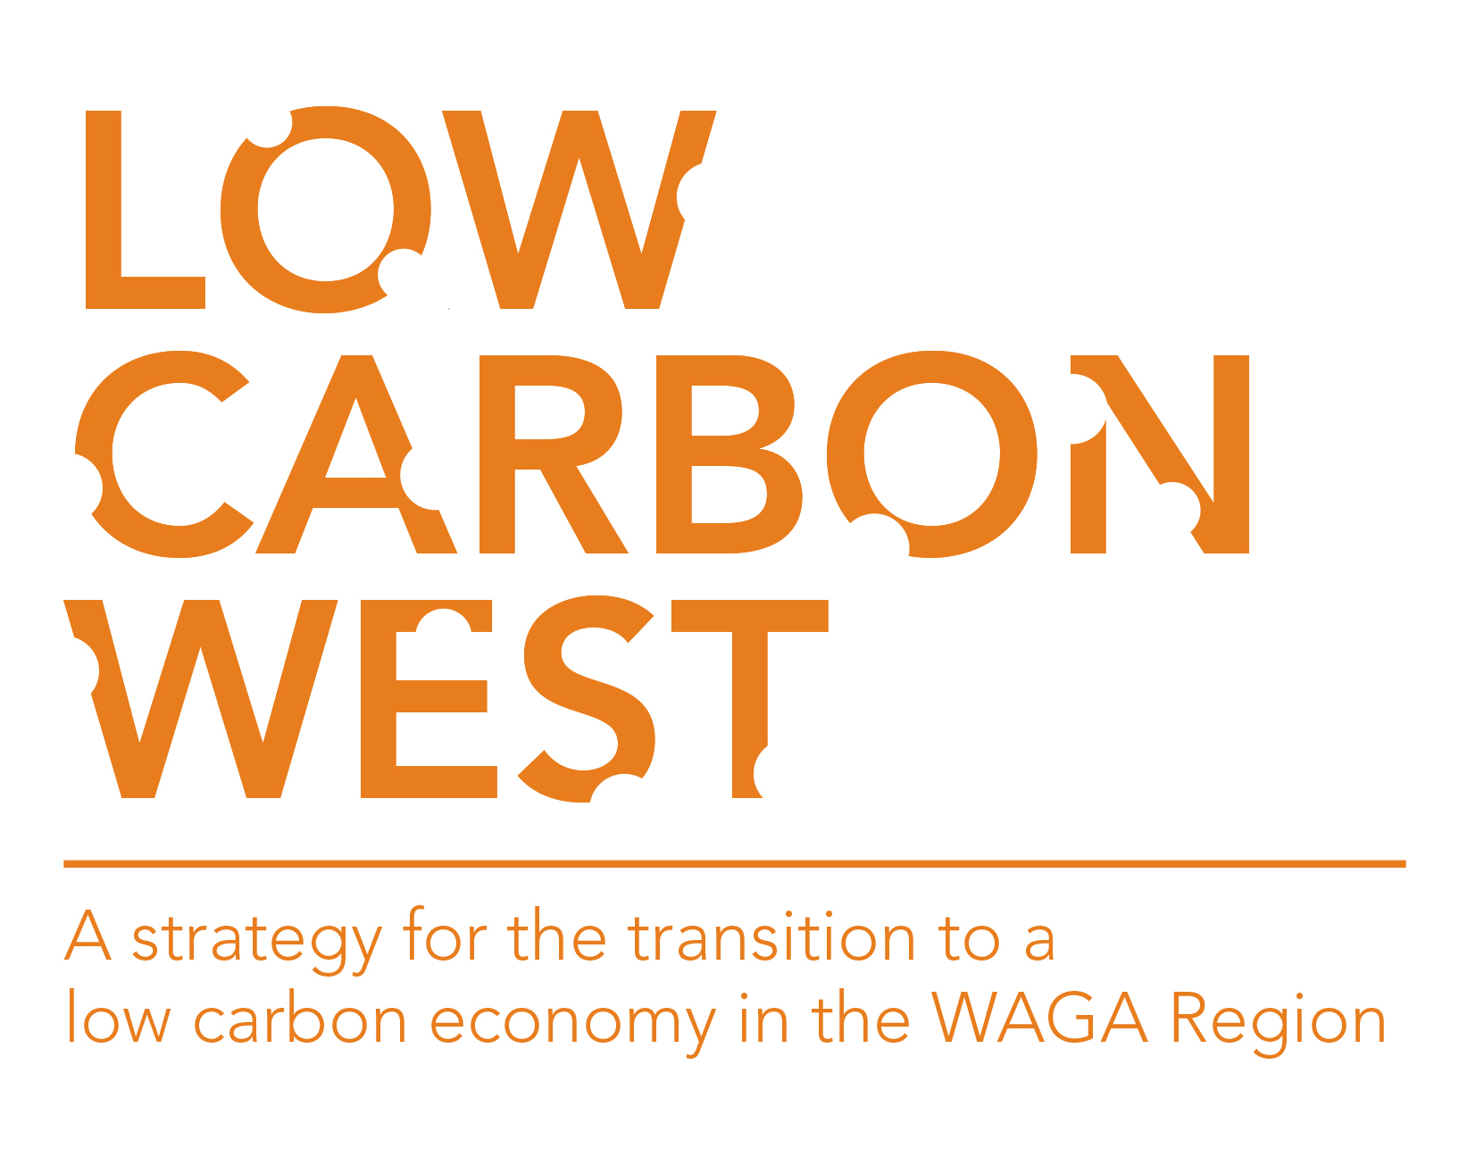

WAGA's budget 2014-2015

|  |  |  |
| --- | --- | --- |
| ITEM | BUDGET | TOTALS |
| INCOME |  |  |
| Member council contributions | $112,000 ($16,000 per financial council |  |
| Member contributions to How Well Are We Adapting | $20,000 |  |
| Investment interest | $10,000 (reduced from $20,000 originally forecast) |  |
| Victorian Adaptation and Sustainability Partnership (VASP) grant | $82,000 |  |
| Transfer from Reserves | $122,000 (including $20,000 remaining from VASP payment made in 2013-2014) |  |
| TOTAL INCOME |  | **$346,000** |
|  |  |  |
| EXPENSES |  |  |
| Salaries and on-costs | $161,981 |  |
| Operating expenses | $20,705 |  |
| Consultants | $118,000 ($88,000 for How Well Are We Adapting: literature review, consultation workshops, monitoring and evaluation framework development; $30,000 for completion of Low Carbon West plan) |  |
| WAGA reserve (for contribution towards implementation of Low Carbon West, development of WAGA branding, an information workshop on EUAs and a continuing reserve for 2015-2016), | $45,314 |  |
| TOTAL EXPENSES |  | **$346,000** |

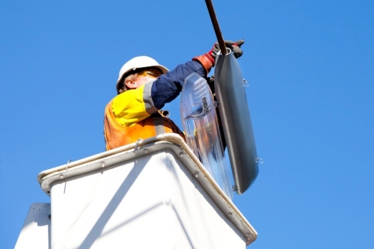

Lighting the West: change-over of street lighting to energy efficient luminaires.

WAGA's administration

WAGA staff are based at Brimbank. They are Fran Macdonald, Coordinator, and Heather McClaren, Climate Change Adaptation Project Officer.

As WAGA's host council, Brimbank City Council employs WAGA's staff and manages all WAGA's contracts and funds on behalf of the WAGA Executive Committee.

Further information

Fran Macdonald

WAGA Coordinator

Website: [www.waga.com.au](http://waga.com.au/)

 (03) 9249 4864

* Franm@brimbank.vic.gov.au