0103

Australia has three and a half levels of government?
Greg Hunt
South East Councils Climate Change Alliance
Victoria, Australia

Abstract
Climate change response is often much more in evidence at the local government level than at state and/or national levels. Local governments are highly responsive to their communities, they have feedback loops between action and response that are almost immediate. But councils often work better within their municipal boundaries than more broadly, even when the issue they are working on is felt regionally. Enter the half level of government!
Local governments working together in groupings based around identity, geography or community can attain the critical mass to conduct research, implement projects and provide services that would not otherwise be possible. Making these collaborations formal is often a missing step.
Victoria's nine greenhouse alliances are successful examples of adjacent councils working in collaboration on climate change response. These alliances are more than just occasional meetings of interested councils though - they are formal entities of a varying number of councils with strong governance, mature strategies for dealing with diversity and a range of ways of working to respond to the breadth and depth of the climate change challenge.
Regional groupings of councils can present all the benefits of local action yet not suffer the distance that often characterises state government action. They show that it is possible to build action on local knowledge without falling prey to parochialism.
In this paper, models of governance and operations for regional alliances will be presented and discussed. The benefits of working regionally will be analysed through case studies of successful programs and projects.

Introduction
The South East Councils Climate Change Alliance (SECCCA) had some data regarding projected climate change for 20 and 60 years hence. This is quite a bit better than crystal ball material as it came from the best models that CSIRO has, the same models that they use in projecting climate change impacts for the IPCC and a range of government agencies across Australia. For example, by 2070, what is currently a one in a hundred year storm surge could be expected to occur every 4 years. Now add this to a sea level rise of a half metre on top of an increased storm tide of another 0.6 metres and this is what residents on the Western Port coast could expect.

When we went to our residents to tell them the story, we went with a long-term local who worked at the council. As the data was being explained with the help of maps drawn from the council’s GIS database, the local was able to point out ‘that in the 1973 flood, remember how the water came around the back of the golf course, up this low land and flooded the houses from behind?’ The nods confirmed that this was not abstract data, it added to real experience and was therefore worthy of being considered and even accepted!

Our residents clearly knew that local was the scale at which climate change adaptation should be done. It’s not the molecules in the troposphere to which we respond, it’s their consequences as the water rises to knee-height, as the relentless sun beats down or as the flash flood rushes down a usually dry gully.
Responsibilities of governments
There are periodic outbursts that Australia is over-governed with MPs and councillors of national, state and local governments clamouring variously for relevance, responsibility and funds. I don’t wish to add another layer but I do wish to argue for climate change responses art a regional level for reasons that I believe are compelling.
Each level has specific responsibilities. The national government includes in its responsibilities oversight for Australia’s international agreements and treaties, it funds national research and it sets standards for national performance. Among the many roles of state government is legislation for and administration of environmental management and planning law. Local government, within its municipal boundaries, does much, much more than the alliterative roles of rates, roads and rubbish. Among the many responsibilities of councils are the implementation of planning schemes, the construction and maintenance of adequate drainage systems, assistance for local businesses and the provision of a range of community services.
Climate change is a challenge to this arrangement. Greenhouse gases are generated through the way we consume goods and services, through our transport systems and through our energy generation and use. The energy generation sector which is within the jurisdiction of national and state governments is a major contributor to Australia’s greenhouse gas emissions so national and state governments must work hand in glove in emissions reduction. If there is insufficient action in emissions reduction, coastal planning schemes, providing services for the elderly in days of extreme heat and ensuring the rapid draining after intense storms are all consequences upon local government. Clearly, local government is vitally interested in the research program into climate change impacts and the standards for risk and infrastructure.

We need governments, with their differing responsibilities, to work collaboratively on both greenhouse gas emissions reduction and on adaptation responses to climate change.
While the Australian government might be remote from the people whose knees are getting wet, it can enact legislation to bring about major change, whether it is in the reduction of carbon emissions by a legislative package that addresses market and non-market failures and barriers to climate change action or directing the insurance industry to offer plain language flood protection policies. State governments that set the planning regimes, that dictate the levels of protection for coastal environments from intensive developments and that establish the emergency response services and systems for community protection can also be removed from the people and the neighbourhoods in which they live. Local government has direct knowledge of their communities, their characteristics and the conditions in which they live and they are called upon to respond quickly to the issues that their residents face.

That they mightn’t provide all of their services with maximum efficiency however, is a function of their very nature. Local council is exactly that; local and the feedback loops with their residents are very short. Spill something on the nature-strip at rubbish bin pick-up, cut down some trees along a creek or leave a pot-hole in a street for even a short time and there’ll be a resident on the phone to register a complaint. Is it any wonder that councils can be seen as reactive in their operations? Spend rate-payers money on anything outside of the municipality and there’ll be quick phone calls to their ward councillor. So while the issue might go beyond a municipal boundary, as climate change issues invariably do, there is a temptation to respond to the issue on a council-by-council basis.

Regional responses

Responding to issues common to many councils on a regional basis can deliver economies of scale. The provision of safe levels of public lighting occupies the thinking of councils across the country, Investigations of available alternative technologies and the business case for bulk purchase of electricity need to be done once by one team and then shared around participating councils. Where adjoining councils share coastal geomorphology and coastal processes, there is clear benefit in collaborating in an assessment of the coastal hazards that they face. Consistent communications for the many issues councils raise with their communities and developing in concert with other councils the advocacy positions that they put to other spheres of government are all the stronger for the clout when made on behalf of greater numbers of people.

Issues can require a regional response. For example, catchment flooding might cross many boundaries so the unit is the catchment, not the political grouping. Catchment modelling will cross these boundaries and the obvious and common-sense response is a catchment response. Storm surges and erosion occur up and down the coast across adjacent council borders. A sensible response is a collective response. Extreme temperatures sear people across whole suburbs and regions and the responses that councils make for their own residents are mirrored by bordering councils. Collaboration in developing responses to all of these issues and then applying those responses with the communities for which each council has responsibility is a most effective way to proceed.

Regional is right for addressing many of the issues and challenges of climate change. The general public identifies with their community and region – eg Goulburn Valley, northern suburbs, Gippsland. Regions cross municipal boundaries so the right responses involve councils forming greenhouse and climate change alliances. There are other regional groupings formed for effective responses to other shared issues. Regional Development Australia Committees develop regional infrastructure and economic strategies, while Catchment Management Authorities work on natural resource management on a catchment scale.

There are some ground rules to be observed however, for collaborations between independent entities, councils with statutory responsibilities and distinct communities and styles, don’t happen by themselves.

Formal alliances

Victoria’s greenhouse alliances are successful examples of local government collaboration. These alliances are more than just occasional meetings of interested councils though – they are formal entities with strong governance, mature strategies for dealing with diversity and a range of ways of working to respond to the breadth and depth of the climate change challenge. And as successful as some collaborations are, we should strive to improve them, to do collaborations as well as can be done!

Greenhouse and climate change alliances offer a range of models of collaboration. Within the groupings that have formed (see Appendix 2), there is still diversity of opinion and approaches. For example, in councils of the northern suburbs which have combined to form the Northern Alliance for Greenhouse Action (NAGA), there is a strong leadership for action on climate change with member councils challenging each other for more effective responses. This leads to a diversity of responses within a core commitment of providing leadership and community service. At SECCCA, councils balance strong difference with shared activity.

Given that these collaboration arise from local conditions they will reflect those conditions and show a wide diversity of members, structures and approaches. What is an appropriate governance model, for there has to be one for all participants to have confidence that their specific issues are not being omitted or subsumed into a general response? Further, they need confidence that their community will not be co-opted into a response that does not service their needs?

Governance

Alliances have differing memberships, differing operations and also differing governance models. Whichever model they have, their governance structures are formal, as are shown in the two examples below.

SECCCA follows the Model Rules for Incorporated Associations established by Victoria’s Office of Consumer Affairs, albeit varied to take its purposes and operations into account. Members are nominated by their Councils onto the Management Committee so involvement in SECCCCA and its committees is a recognised element in their work programs. For council staff to be able to dedicate time to alliance work, their alliance responsibilities and work commitments need to be internalised and become a component of their own Council work plans and annual business plans, rather than being seen as additional to their council role.

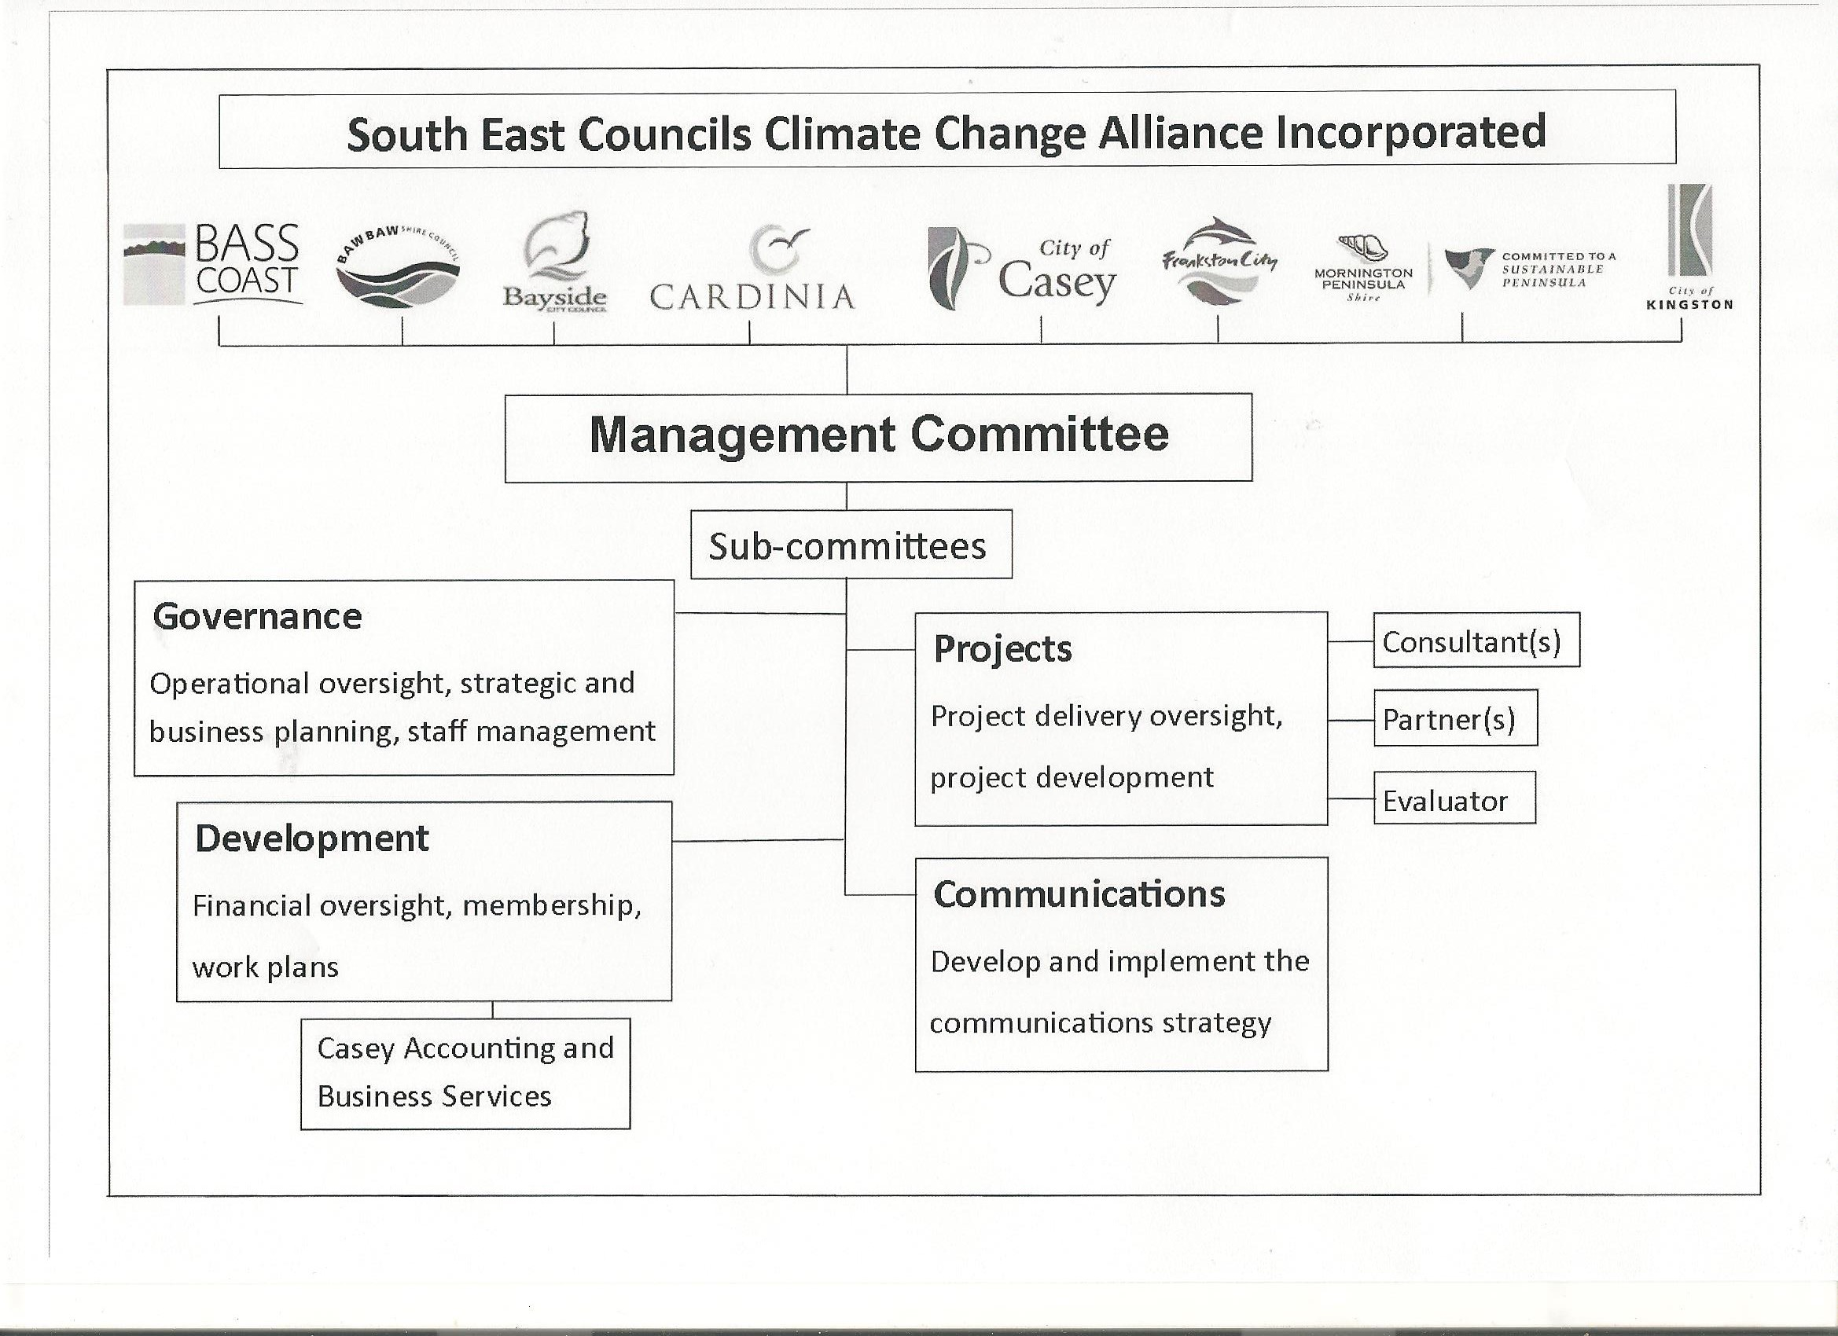

There are Role statements for Office Bearers and Terms of Reference for the Sub-Committees. Membership of and participation in the alliance is the subject of a regularly renewed Memorandum of Understanding. SECCCA staff work directly for the incorporated association and are provided with accommodation and services on a fee-paying basis by a member council. Being sited within a council is a daily reminder that a council’s concerns are SECCCA’s concerns.

SECCCA brings in external service providers to implement projects, contracting in the capacity to deliver across the range of projects conducted. Because council staff involved in the Management Committee are nominated formally into the role, oversight of SECCCA’s projects is their own work programs.

NAGA governance structure

NAGA is a grouping of nine councils from the City of Melbourne, the major capital city council to the city edge councils of Whittlesea, a growth are council on the urban fringe and the quite forested council of Nillumbik. In between are established suburbs with quite diverse populations. Working across this breadth of community clearly must be well considered.

NAGA has member councils that lead implementation of specific projects and implementation; whilst NAGA member the Moreland Energy Foundation Limited (MEF)L plays a lead role in governance, employing NAGA’s Secretariat staff and overseeing governance structures and functions. This ensures sound and effective decision-making; incorporates processes for accountability to the alliance and to individual alliance members and maintains effective communication and information exchange within NAGA’s network.

The NAGA Executive has senior local government (including Councillors) as members.

NAGA Secretariat
Executive Officer
Project Manager
NAGA Executive
Implementation forum
Advocacy Executive Working Group
Finance Executive Working Group
Working Group
Working Group
Governance Executive Working Group
Working Group

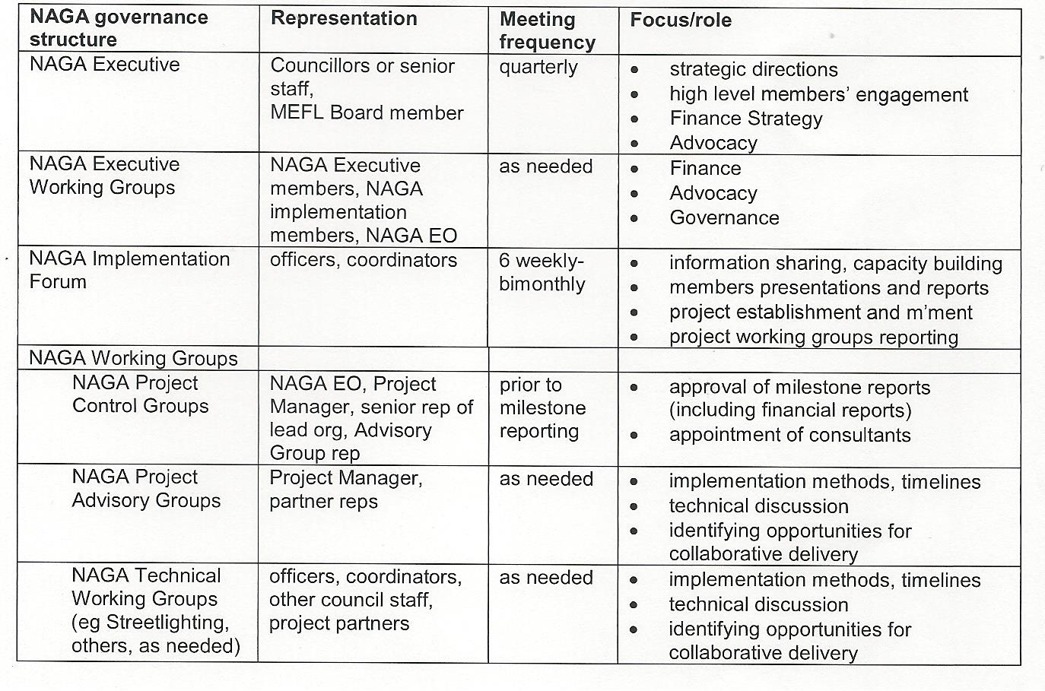
Western Alliance for Greenhouse Action (WAGA) Governance Structure

WAGA Executive Committee

- One senior manager from each member council.
- A Chair is elected annually from the committee members.
- Responsible for strategic direction, political support, financial contributions and annual budget.
WAGA Operational Committee

- Operational staff from each member council.
- Develops WAGA’s Annual Implementation Plan and projects for endorsement by the Executive Committee.
WAGA Working Groups

- Established as needed and accountable to the WAGA Operational Committee.
- Non-WAGA committee members may be co-opted.
WAGA Coordinator

The WAGA Coordinator works with the Operational Committee to develop the Annual Implementation Plan and projects, facilitates the work of the Operational Committee and Working Groups, and is directly accountable to the Executive Committee.

At WAGA, individual councils have taken the lead on previous projects with a new staff member being employed recently to conduct an adaptation project for the alliance on behalf of member councils. Council staff leading projects has the effect of distributing the work across member councils and draws staff into the regional actions. Conversely, it has the issue of only being as fast as the individual officers work program on behalf of her/his employing council allows.

Projects

All the Alliances have been involved in energy efficiency and renewable energy projects with their members and communities. The Central Victorian Greenhouse Alliance has been conducting a behaviour change project in Castlemaine and Kyabram. Both the South East Councils Climate Change Alliance and the North East Green House Alliance are working with their farming communities and their schools to reduce emissions. The Central Victorian Greenhouse Alliance worked with 17 of its schools to create major reductions in their energy use and this has sparked other projects.

NAGA has also achieved substantial progress in installation of energy efficient public lighting, through partnerships with state government departments, electricity distribution businesses, lighting manufacturers, the other Regional Alliances and communities.

SECCCA’s councils recently participated in the Victorian Department of Transport’s Electric Vehicle trial to investigate how much service delivery travel within a council could be provided by electric vehicles and what are the issues in using such vehicles. An eco-driving pilot conducted through the works depots at three councils showed that a reduction in fuel use of around 16% was readily achievable through changing driving behaviour,

The Western Alliance for Greenhouse Action (WAGA) project Lighting the West will involve replacing 26,000 street lights with more efficient lights, to result in energy savings annually of 6.5 million kWh, annual greenhouse gas emission reduction of 7,737 tonnes CO₂e (150,000 tonnes over 20 years) and the expenditure over councils of $8.5 million. These are the large scale projects, usually beyond the capacity of an individual council, that alliances conduct.

Adaptation is also core business for Alliances. WAGA is developing a Regional Climate Change Adaptation Strategy and Action Plan for the 8 member councils. The South East Councils Climate Change Alliance conducted the project Impacts of Climate Change on Human Settlements in the Western Port Region: An Integrated Assessment. This project, funded by the then Australian Greenhouse Office and the Department of Sustainability and Environment, featured a partnership of the CSIRO, Marsden Jacob Associates, Broadleaf Capital International Pty Ltd (risk assessors) and the Regional Development Company (facilitators and evaluators). The CSIRO was commissioned to carry out modelling for the likely biophysical impacts due to climate change in the Western Port region.

Councils then described the communities and the infrastructure for which they are responsible that might be vulnerable to impacts such as storm surges, high winds, extreme rainfall, high temperatures, etc. The councils then conducted risks assessments to help them consider appropriate adaptation responses. This was one of 5 federally-funded Integrated Assessment adaptation projects that broke new ground in preparing community responses to climate change. Members councils using the data generated from this project are now building climate change responses into their programs and services.

Some alliances have also brought together partners to develop carbon sequestration projects. South East Councils Climate Change Alliance is implementing ways to offset the carbon that member Councils produce through their operations via a biodiversity planting in their first carbon sink at Bunyip, while their second has now been planted on a high-visibility site on the Monash Freeway. The North East Green House Alliance is mapping appropriate local government owned sites and assessing their future carbon trading potential, evaluating current planting programs for their value as carbon sinks and developing planting programs to maximise carbon sequestration. The Central Victorian Greenhouse Alliance has worked with Bendigo Bank and Greenhouse Balanced to develop a local carbon sequestration project.

Alliances bring externally-derived funding support for the many projects that their councils might wish to undertake but acting alone, could not bring about. For example, since its inception, the South East Councils Climate Change Alliance has brought in more than $6.5 million to climate change response across its member councils. This support is project based, not core funding based and relies on the networks established by the Alliance. The Appendix SECCCA: local governments in the south-east responding to climate change lists many projects in which SECCCA has been involved.

Regional collaborations

There is also collaboration in projects on a meta-level. Alliance coordinators meet regularly to share information, discuss issues and develop strategic responses for consideration by their council members. These range from considering internal matters of alliance operations, drafting of submissions to Victorian and Australian Government policy papers and collaborations for shared projects.

Council Connections

Council staff come to their regional coordinator for advice regarding where are there responses to an issue that they face and from which they can learn. Through the networks of alliance coordinators we know of many responses to many issues and we can ask up to coordinators, they ask across to other alliances who ask down to their council members for example responses to the issue and the process could be repeated through the formal channels and hierarchies to provide some answers to the original question. How much better to put the questioner in direct contact with the answerer?

This would imply the questioner knowing who is around doing similar work in different regions, knowing what work they are doing and have a sufficient relationship to make the contact and ask for assistance. Councils Connections, conducted in conjunction with the Victorian Centre for Climate Change Adaptation Research, was a project response involving three Melbourne metropolitan alliances and their 25 councils in establishing a community of sharing and learning on these issues.

Alliance coordinators agreed on the pressing climate adaptation issues that their councils were asking them about; (i) legal risk, (ii) urban planning and (iii) public health and social issues. A program was created to explore the basis of the issue, how climate change made it more an issue, where were there good examples of responses to the issue and then what did they see were explicit council needs for responding to the issue.

In collaboration with the Municipal Association of Victoria (MAV), NAGA, SECCCA and WAGA conducted a series of workshops designed to investigate the selected adaptation issues and importantly, to develop an adaptation community across the councils that the alliances represent.

A similar format was followed at each workshop, which was led by a skilled and experienced facilitator. A keynote address given by a cutting edge professional in the issue so that the implications could be laid bare for all to consider. A follow-up address was given by a practitioner who has delivered a response, at least in part, to an aspect of the issue. The facilitator led a formal workshop for all participants to identify the myriad questions that arose from considering the issue within the context of their council and their community. These were then clumped for determining those that were common across councils so that time could be given to brainstorming possible responses and further issues that need to be addressed.

Through this format the organisers were able to achieve the real benefit from Council Connections – that of the development of an adaptation community; council staff who know their counterparts at other councils, know of the issues they face and the ways that they are responding and are confident in making contact and discussing possible approaches to their common issues. The keynote addresses, the issues and implications and the possible responses were posted on the MAV website for ongoing use.

Benefits of Alliances

Greenhouse Alliances have helped fill many of the resource gaps for local councils, particularly those in regional areas that are not well-resourced with funds, time or knowledge, or those that are undergoing massive development.

As a result of the formal involvements in alliances, member councils are involved in a greater range of projects than would otherwise be the case. Member councils attest to the benefit in membership as follows:

Through involvement in SECCCA, our council does projects that it wouldn’t do otherwise
Our councils have more power when we act on a regional basis
There is a synergy through involvement in the SECCCA, we are greater than the sum of the parts
Involvement in SECCCA allows us to avoid duplicating efforts and so achieve economies of scale

Conclusion

Alliances (i) provide formal mechanisms to give different groups confidence in collaborating on complex issues; (ii) they scale up local issues into broad-ranging strategic contributions through projects and project advocacy; (iii) they communicate the need for urgent and deep action. They are well respected within their regions and provide positive material for local media to convey the urgency of climate change; and (iv) they link the partners that are needed to help community, industry and other organisations adapt and thrive in a low emissions economy.

And they can continue to: (i) work with their local communities to support them to make the change to a new way of living. They are already doing this with their projects. It is interesting to note that in Greenhouse Alliance areas the community is very active. In the Central Victorian Greenhouse Alliance area alone there are 10 local climate action groups dedicated to reducing the CO₂e emissions in their community. The Northeast Greenhouse Alliance has at least 5 groups active in their area; (ii) work efficiently, effectively and cooperatively across regions as a network of Regional Alliances on issues of state or national scope or importance; and very importantly for local councils they; (iii) attract funds into the regions from many different sources.

Australia probably doesn’t need a further level of government, but as organisations that sit between local government and state government and that aggregate the concerns of local government into effective interactions with state government, Victoria’s formal greenhouse and climate change alliances are strong contributors to the climate change response.

Greg Hunt
Executive Officer
SECCCA
C/- City of Casey
P O Box 1000
Narre Warren Vic 3805
Ph 0400 948 546

Acknowledgement
Significant contributions to this paper were made by my ‘AGA’ colleagues, NAGA’s Judy Bush and WAGA’s Fran MacDonald. They should be contacted directly (see Appendix 2 for details) for further information about their structures, processes and work programs. The views expressed here do not necessarily represent the views of other Alliances or their individual members.

